


Do you have a Child Protection Concern?
If so:-

- Speak with Anthony David or Jo Mould (Designated Safeguarding Leads) as soon as possible.

- If unavailable, speak with Jo Wilson or Donna Bedford (Deputy Designated Safeguarding Leads).

- It is essential that you report your concerns verbally at the absolute earliest opportunity.
Designated Safeguarding Leads
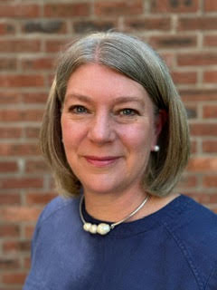
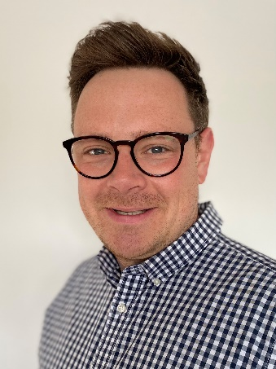
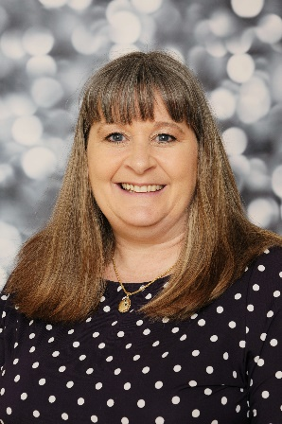

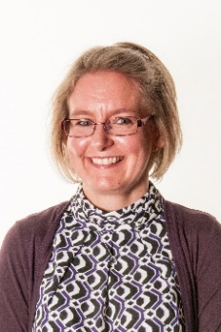
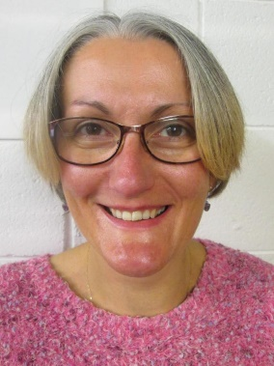
In the event of a DDSL being unavailable please contact:
Jo Wilson
DDSL
Helen Smith
Business Manager
Jo Mould
DSL Deputy DSL
Anthony David
DSL
Donna Bedford
Deputy DSL Deputy DSL

